Event | How many? | How far? | How long in seconds?
Speed Bounce
Keep Ups
Distance Run
Spell Your Name- how many letters and how long did it take?
Stair Challenge - up and back down is one rep.
Hot Potato
Sock Toss
Book Balance
Plank
Handstand Hold
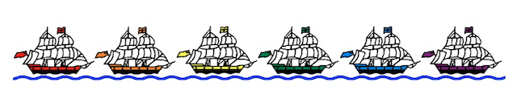
Name ______________________ Year Group _____________

Packet ship ____________________________

