Parliament Achievements
2019-2020

The Cabinet
Our cabinet members are 2 representatives from each class who share any views from each class or ideas for developments within school. We meet every week to discuss school life and check the school letter box. We meet with the chairs of each working group once a term for our star chamber meetings where we learn about the developments of each project in the school. The chairs may ask us for financial help or to present ideas to the whole school in assembly.
This year we were invited to Falmouth Town Council Chamber to meet the Mayor. We explained to the Mayor how our parliament worked at school and showed him our agendas and minutes. He was very impressed with how everything was run and organised. We took back some new developments from the visit to improve our cabinet further. We think that members should stand when they want to share an item from the agenda and that the chair of Cabinet should float between working parliament groups rather than being a fixed member. We have been invited back to hold a full star chamber meeting in the council chamber.
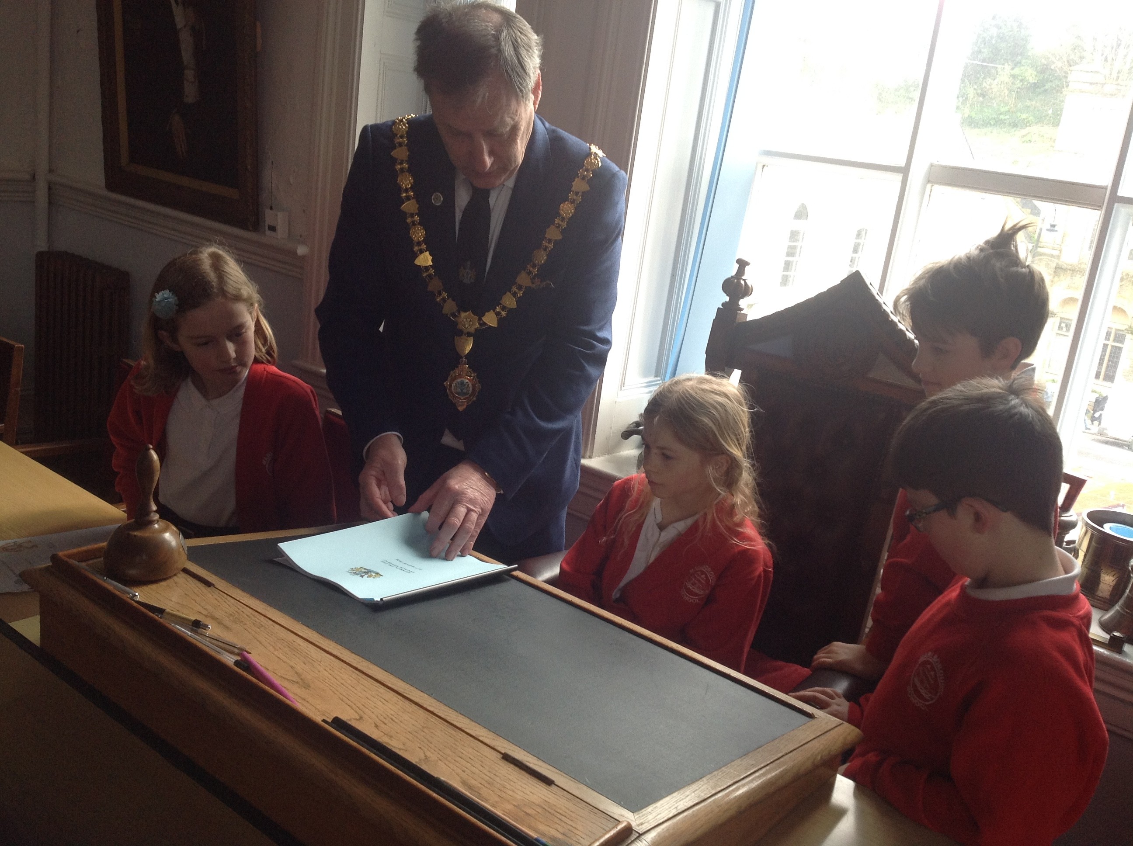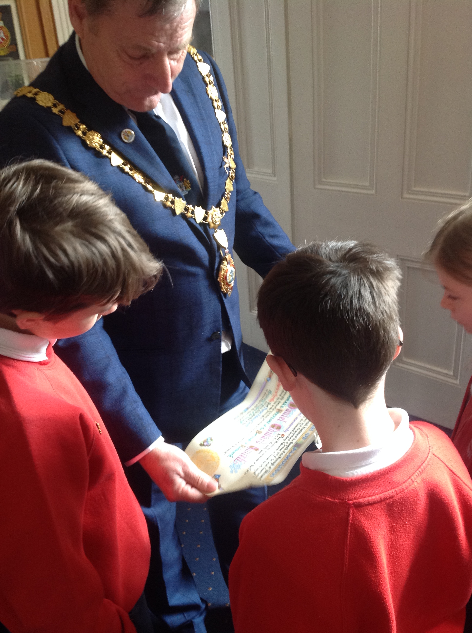

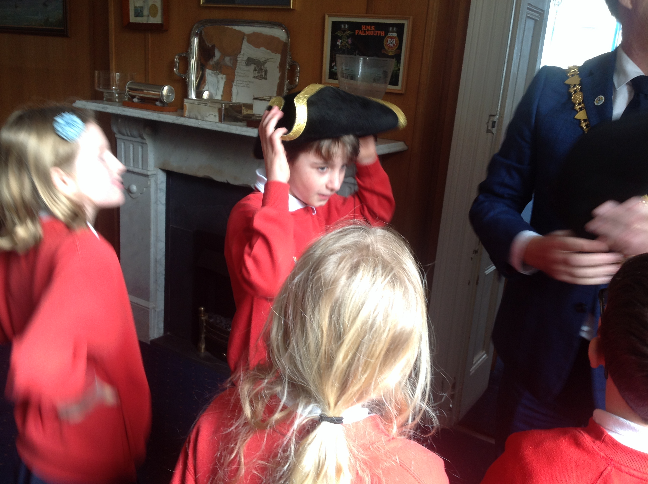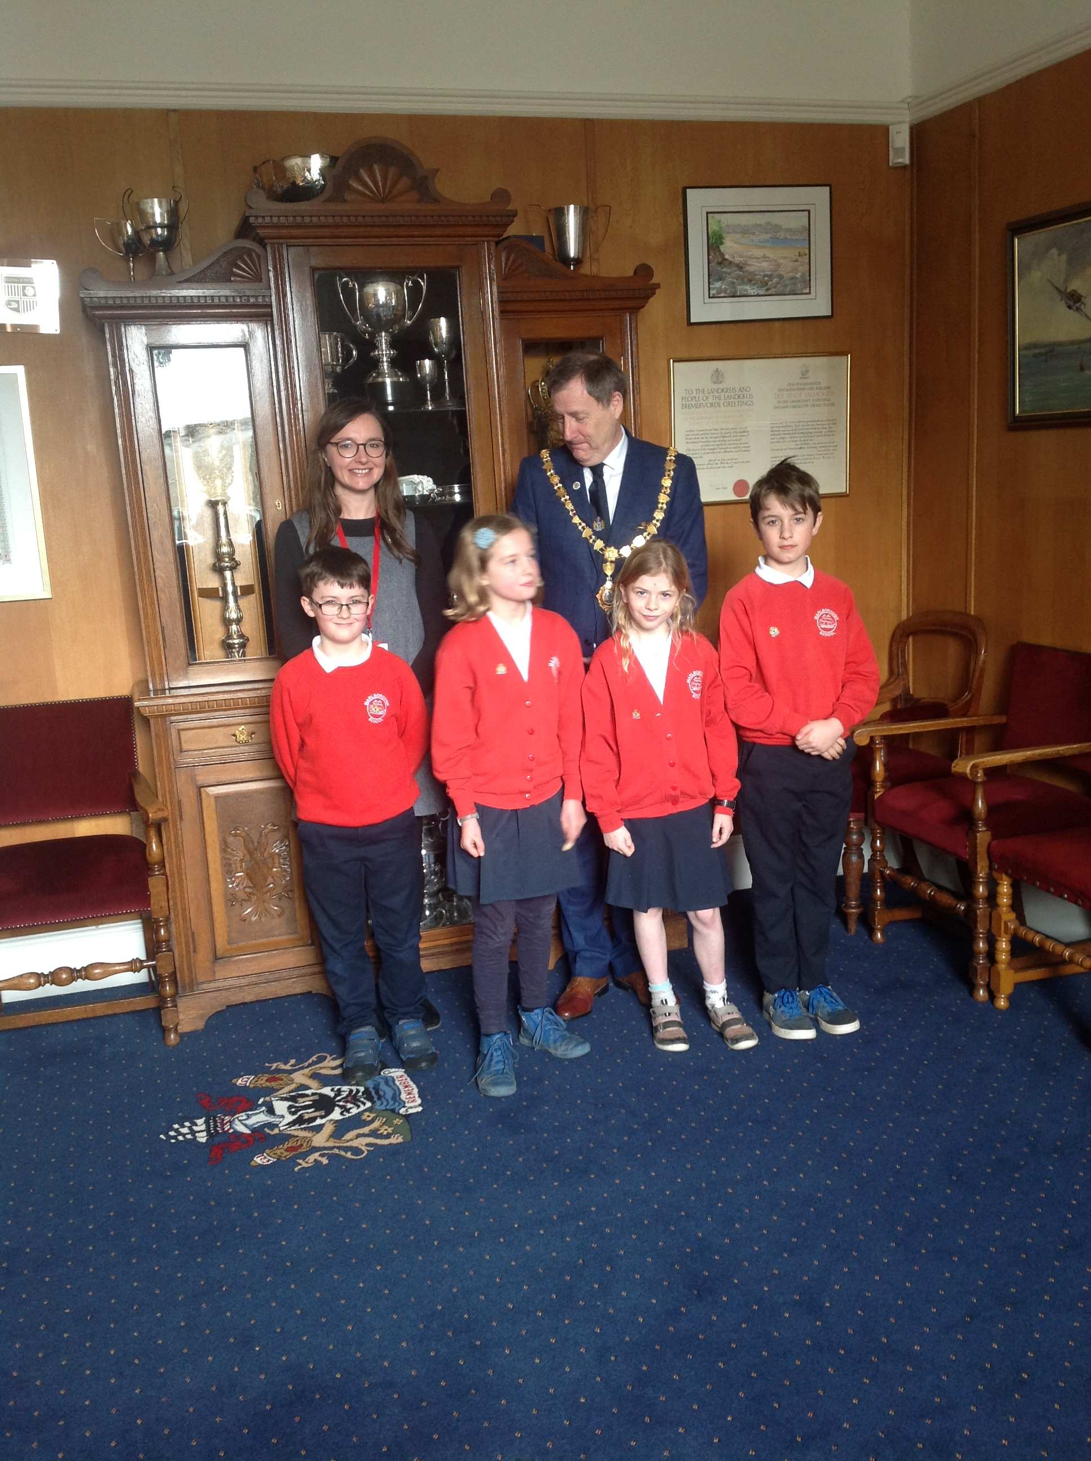

Learning Group
With the support of University students, parent helpers and the Mariners our learning group made our new library vision a reality! The area was completely transformed from a computer suite to a brand-new forest themed library! We designed the space thinking carefully about where the furniture could go, what furniture we’d like and the colour scheme. Parents came in for painting parties after school to give the place a lick of paint and we even had new carpet fitted. The Education library service came in to help us organise the space into a functioning library using the dewy system. We created application forms for children to fill in if they expressed an interest to be a librarian. They were interviewed and selected from the interview process. The librarians have a rota and keep the library tidy and user friendly, making sure books are returned to the correct area and that the bean bags are fluffed up!
This project took over a year to make it into “The Burrow” that it is today. We had a grand opening where everyone from the learning group cut the ribbon to open the library. We had a week of words to celebrate the library opening where authors, dancers and actors visited school with workshops for us. Every day we had a surprise storyteller
and we met the screenwriter of Shaun the sheep, James Henry.
.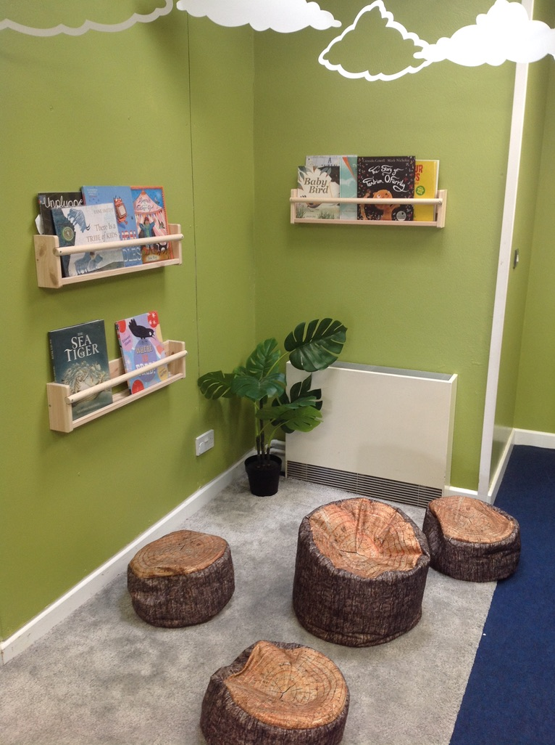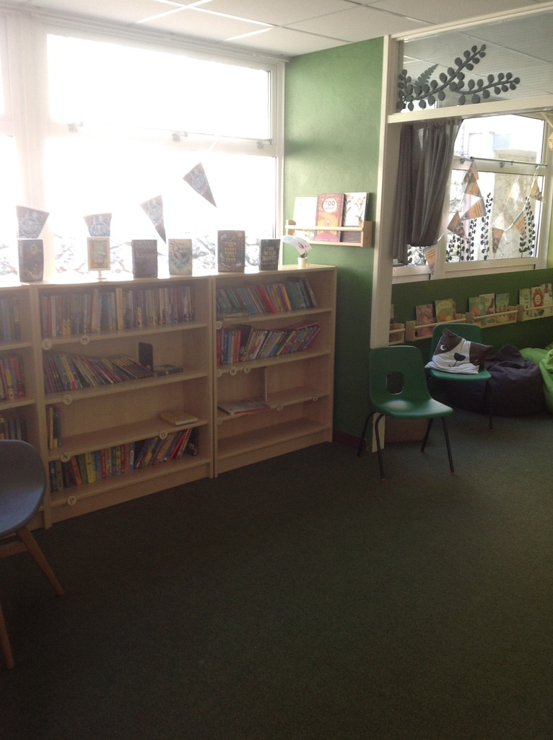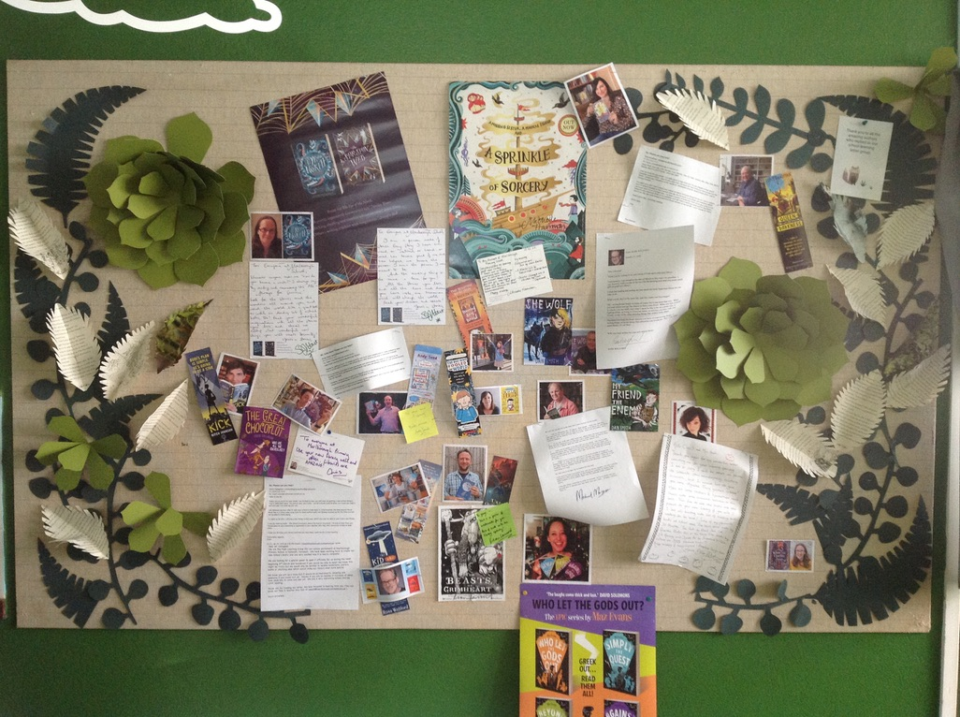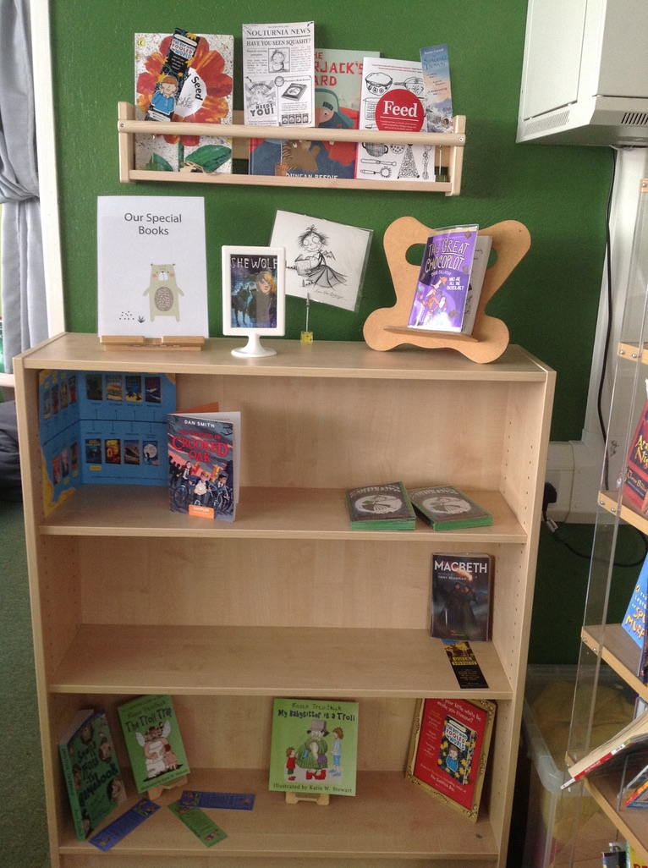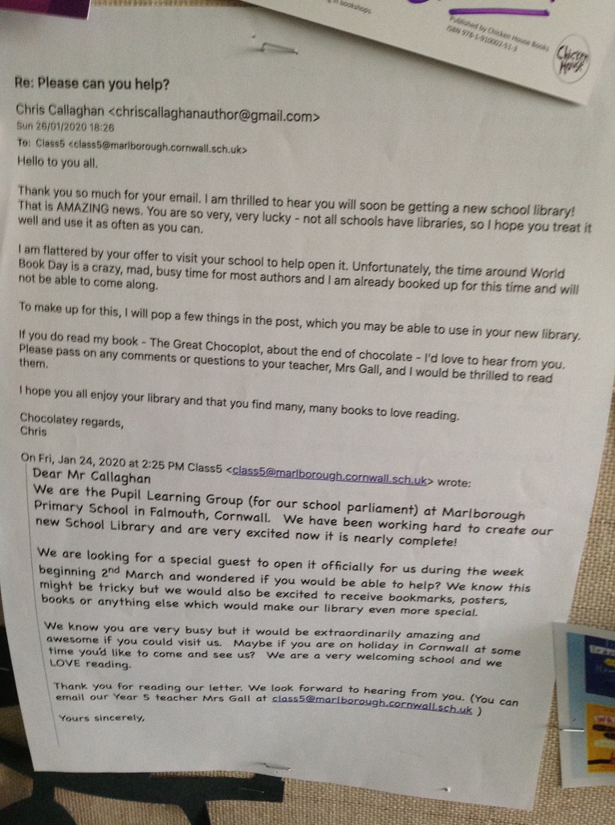

School Environment
This year we wanted to make our school grounds as safe and attractive as possible. Our playgrounds had grey walls and were dull so we all designed a mural that could be painted on the walls. We wrote to the university students who kindly gave their time to include as much of all of our designs as possible. The space is now really bright and a fun place to be!
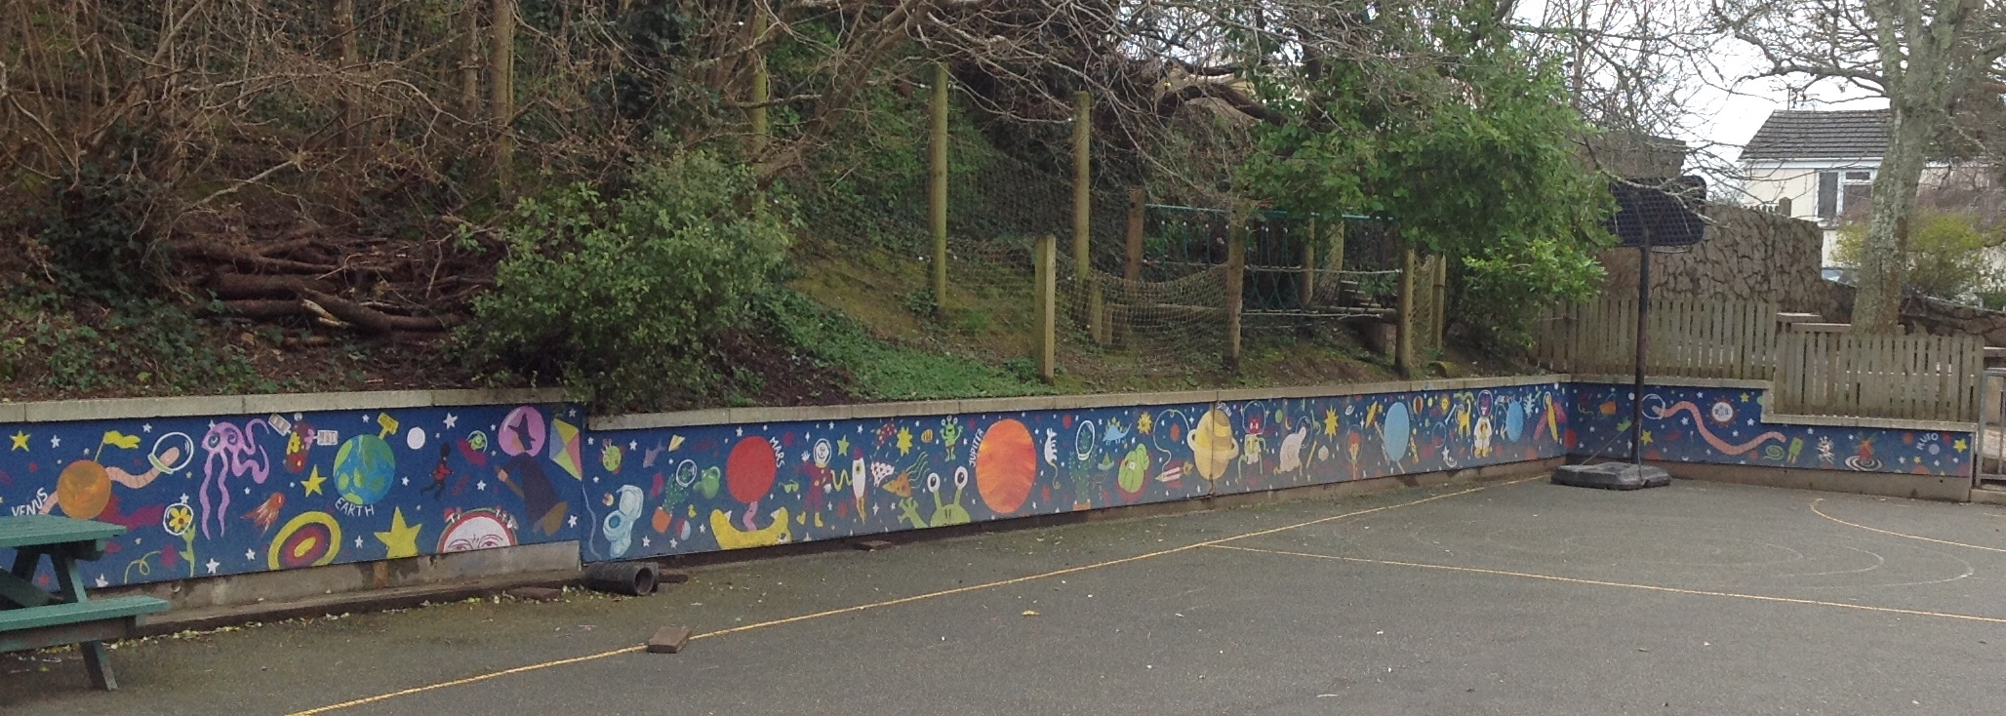

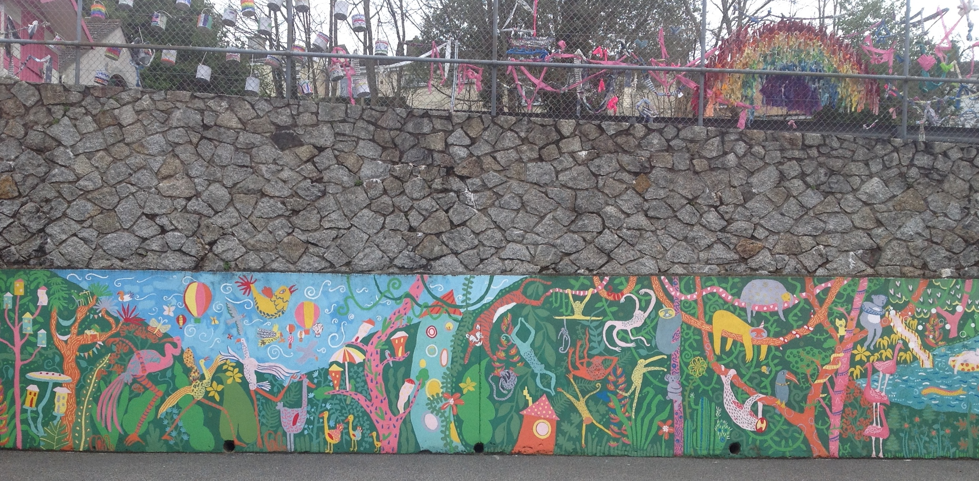
Our second project has been to create a space to read and write outside. We decided that we’d like a shed so we wrote to parents in the newsletter to see if anyone had a shed that they could donate. We were lucky to have 2 sheds donated to us from events square in Falmouth. We have decided to place one in the downstairs playground to keep our outdoor equipment safe and the other one will be our writing shed upstairs. We entered the ‘Think Big’ council competition to try and win money towards making our grounds better but didn’t win this time. We have drawn up a wish list of what we would like in the shed including fairy lights, comfy cushions, lots of different types of paper and pens etc. We will fundraise to be able to get the resources.
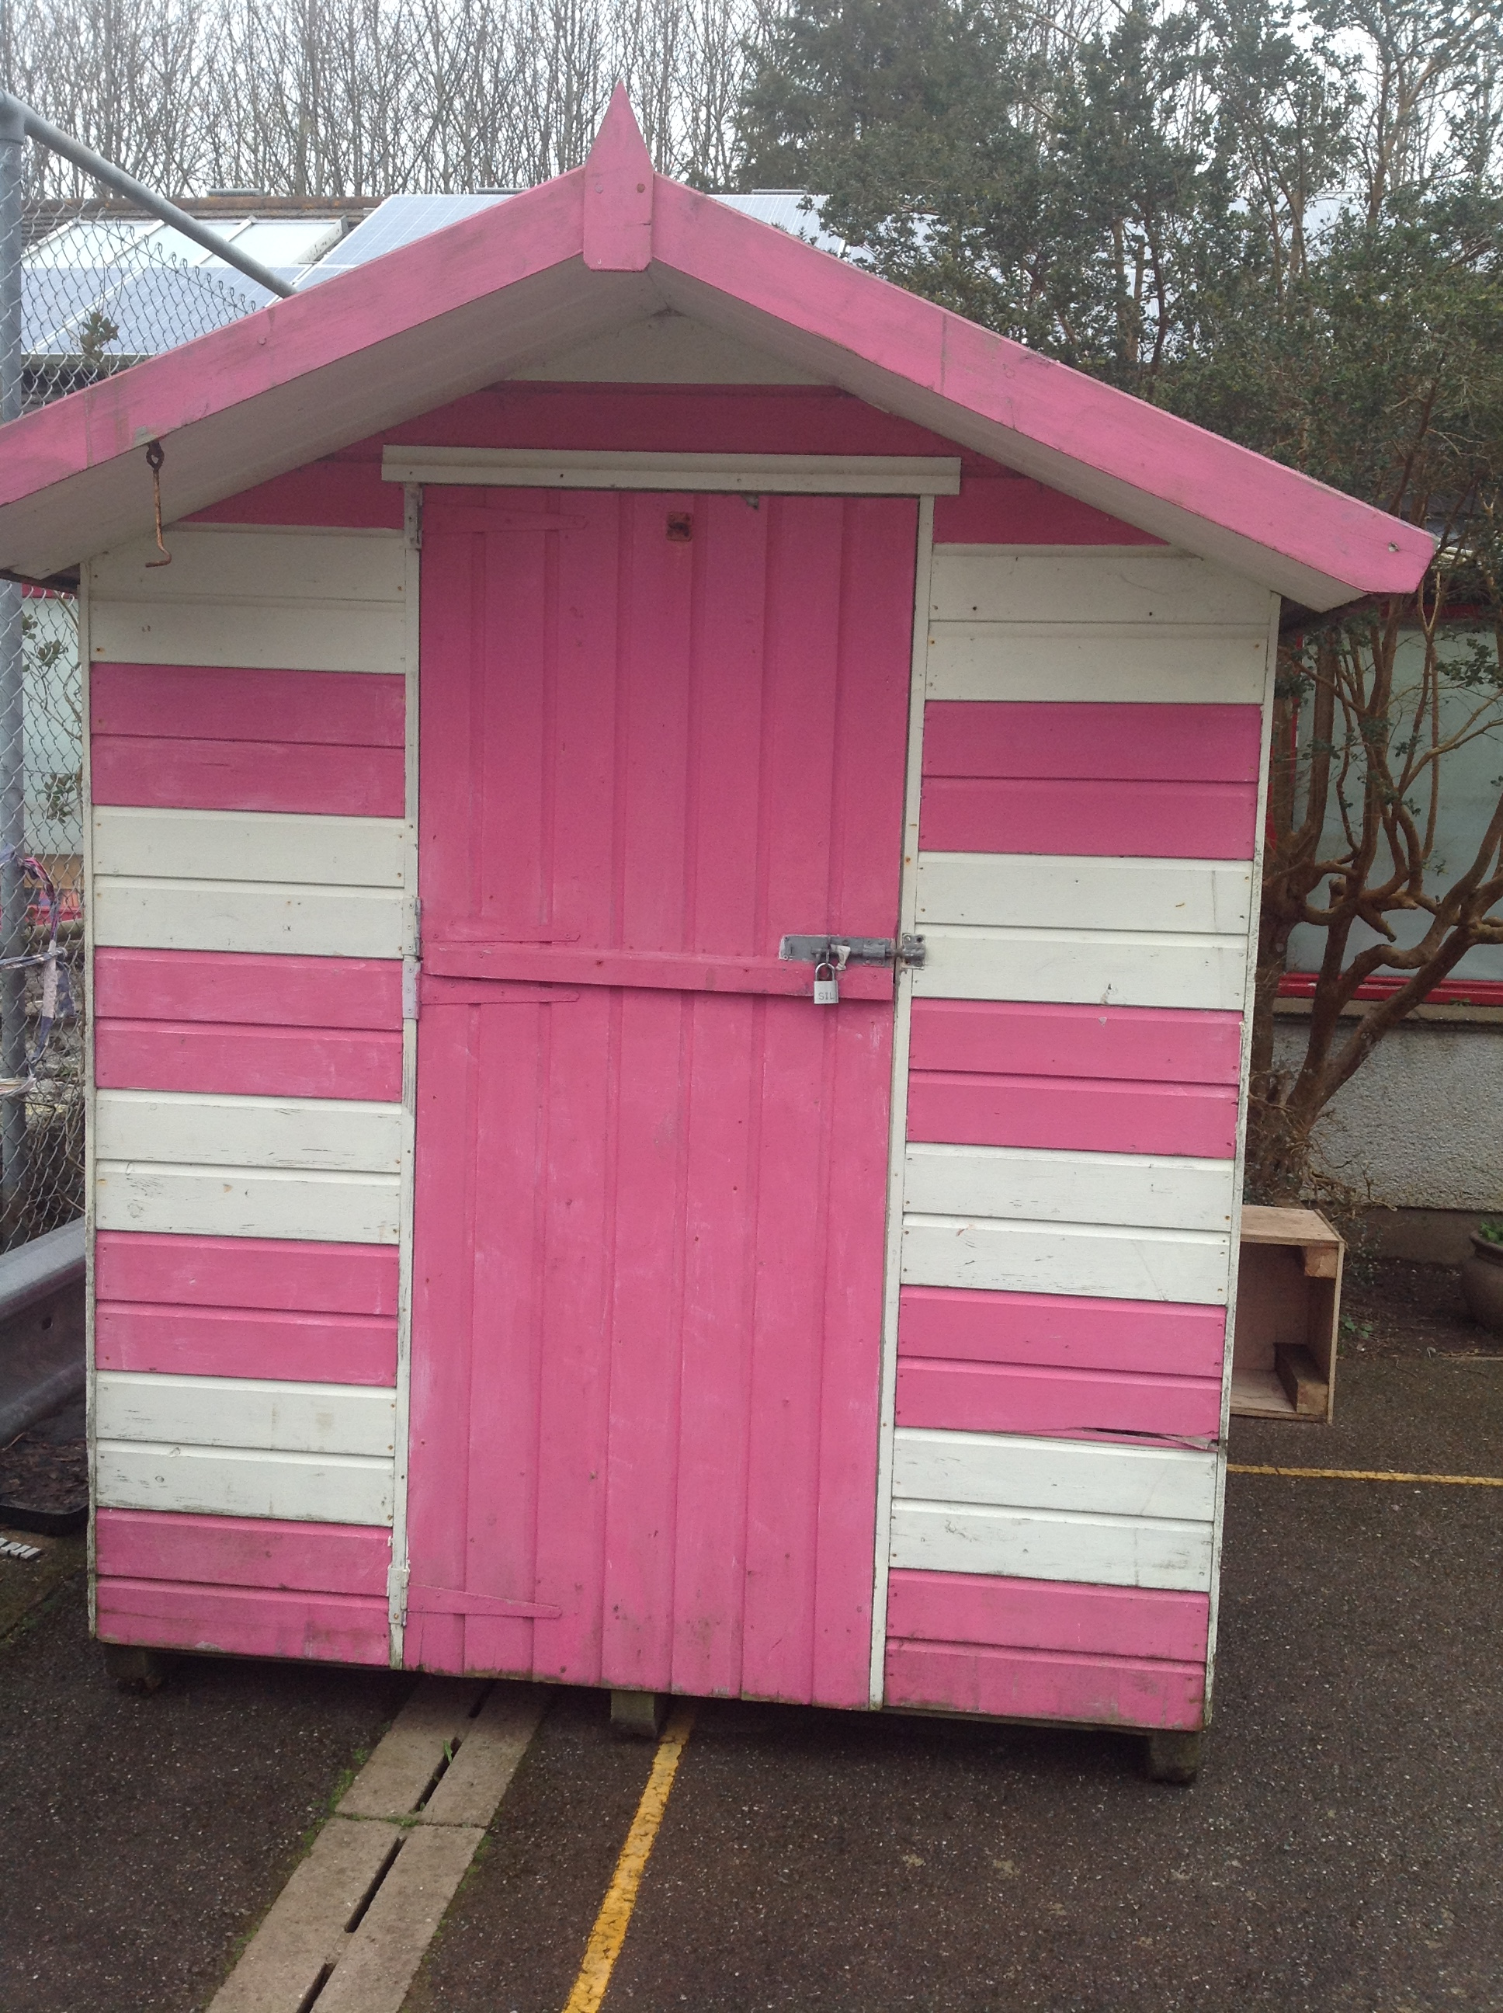

Fundraising
We have taken part in many fundraising days this year to raise money for charities and our school. We all took part in ‘#helloyellow’ on 10th October to support mental health. Everyone was invited to wear yellow and donate to support this cause. We raised - £166.50. Our chair, vice chair and secretary told the school all about the event and counted the donations at the end of hello yellow day.

We also supported Children in Need in November by wearing something spotty and raised - £162.34.
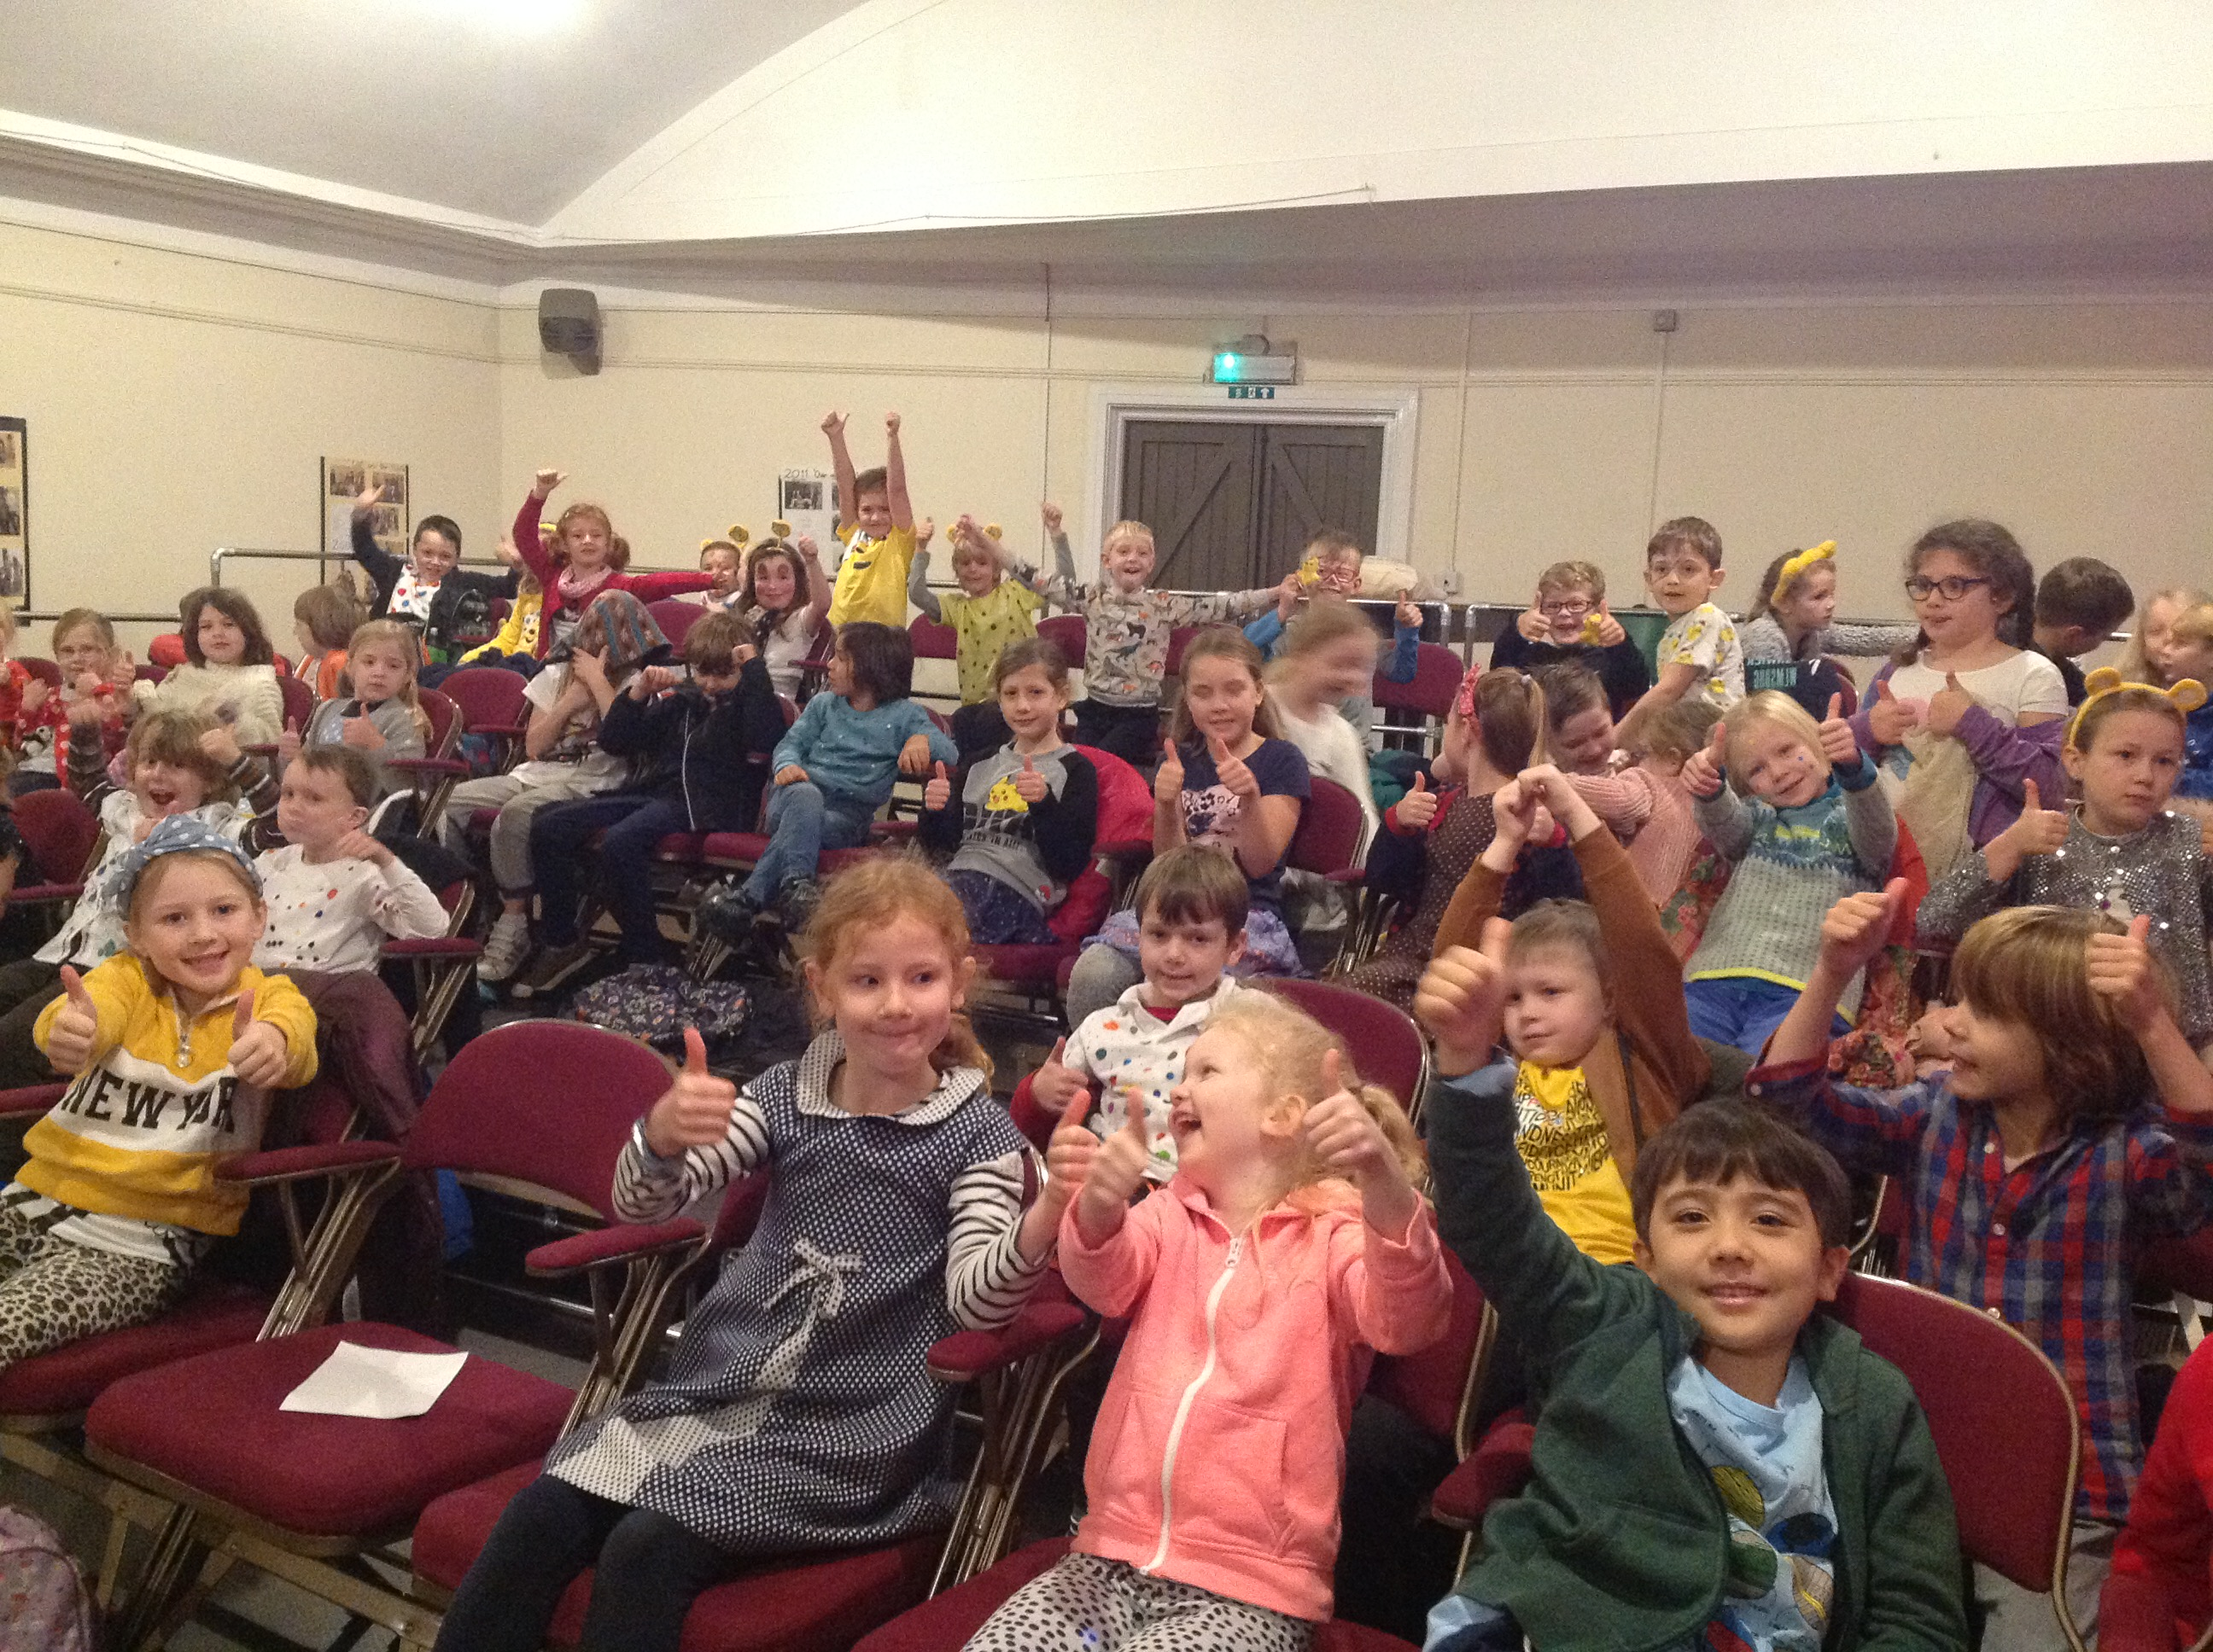

We supported the Australian wildlife bushfires by holding a cake bake in February and raised £167.25.

Local and Global Links
We have been working on improving our recycling in school. We now collect our plastic rather than throw it in the bin and we are looking at linking with local companies to help us with recycling. We looked into the BIC scheme but they are not taking new schools on so we are contacting ‘The Incredible Bulk’ about our recycling scheme. We compost all of our fruit and veg which we use in our school garden. We use vegetables from our allotment where we can so that we are using what we grow.
We are planning on getting in touch with the community heart café in Falmouth to support local people in the community. We sang at old people’s homes at Christmas time so that they could enjoy hearing some Christmas songs and see our smiley faces.
We helped plan activities for ‘The Big Dig’ with our parent helpers and we created a bug hotel in our school grounds to support local wildlife.
We are planning on taking part in the Spring Flower Festival by helping with the new planting at Gyllngdune gardens. We are also planning on carrying out a beach clean as a group on our local beach, Swanpool.

Food
Our big project this year has been to get the tuck shop up and running again. We did a lot of research into the food that we would like to sell, suppliers and costing out the food. We have changed the sale time to break time and we have smoothie Fridays. We asked people what they would like to buy and used last year’s receipts to remind us of the popular food. We place an order with our teacher who buys it, we then prepare it and sell it. There is a rota for the week and our accounts manager counts up the money at the end of the week. We sell all of our fruit and vegetables for 20p and it runs at a profit which we use to buy more produce.

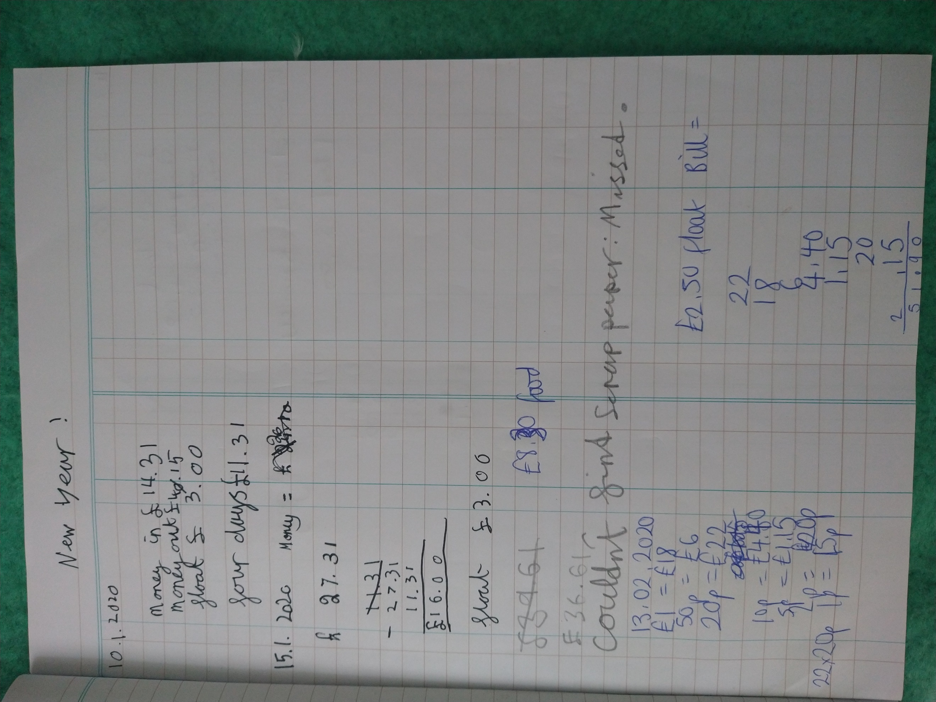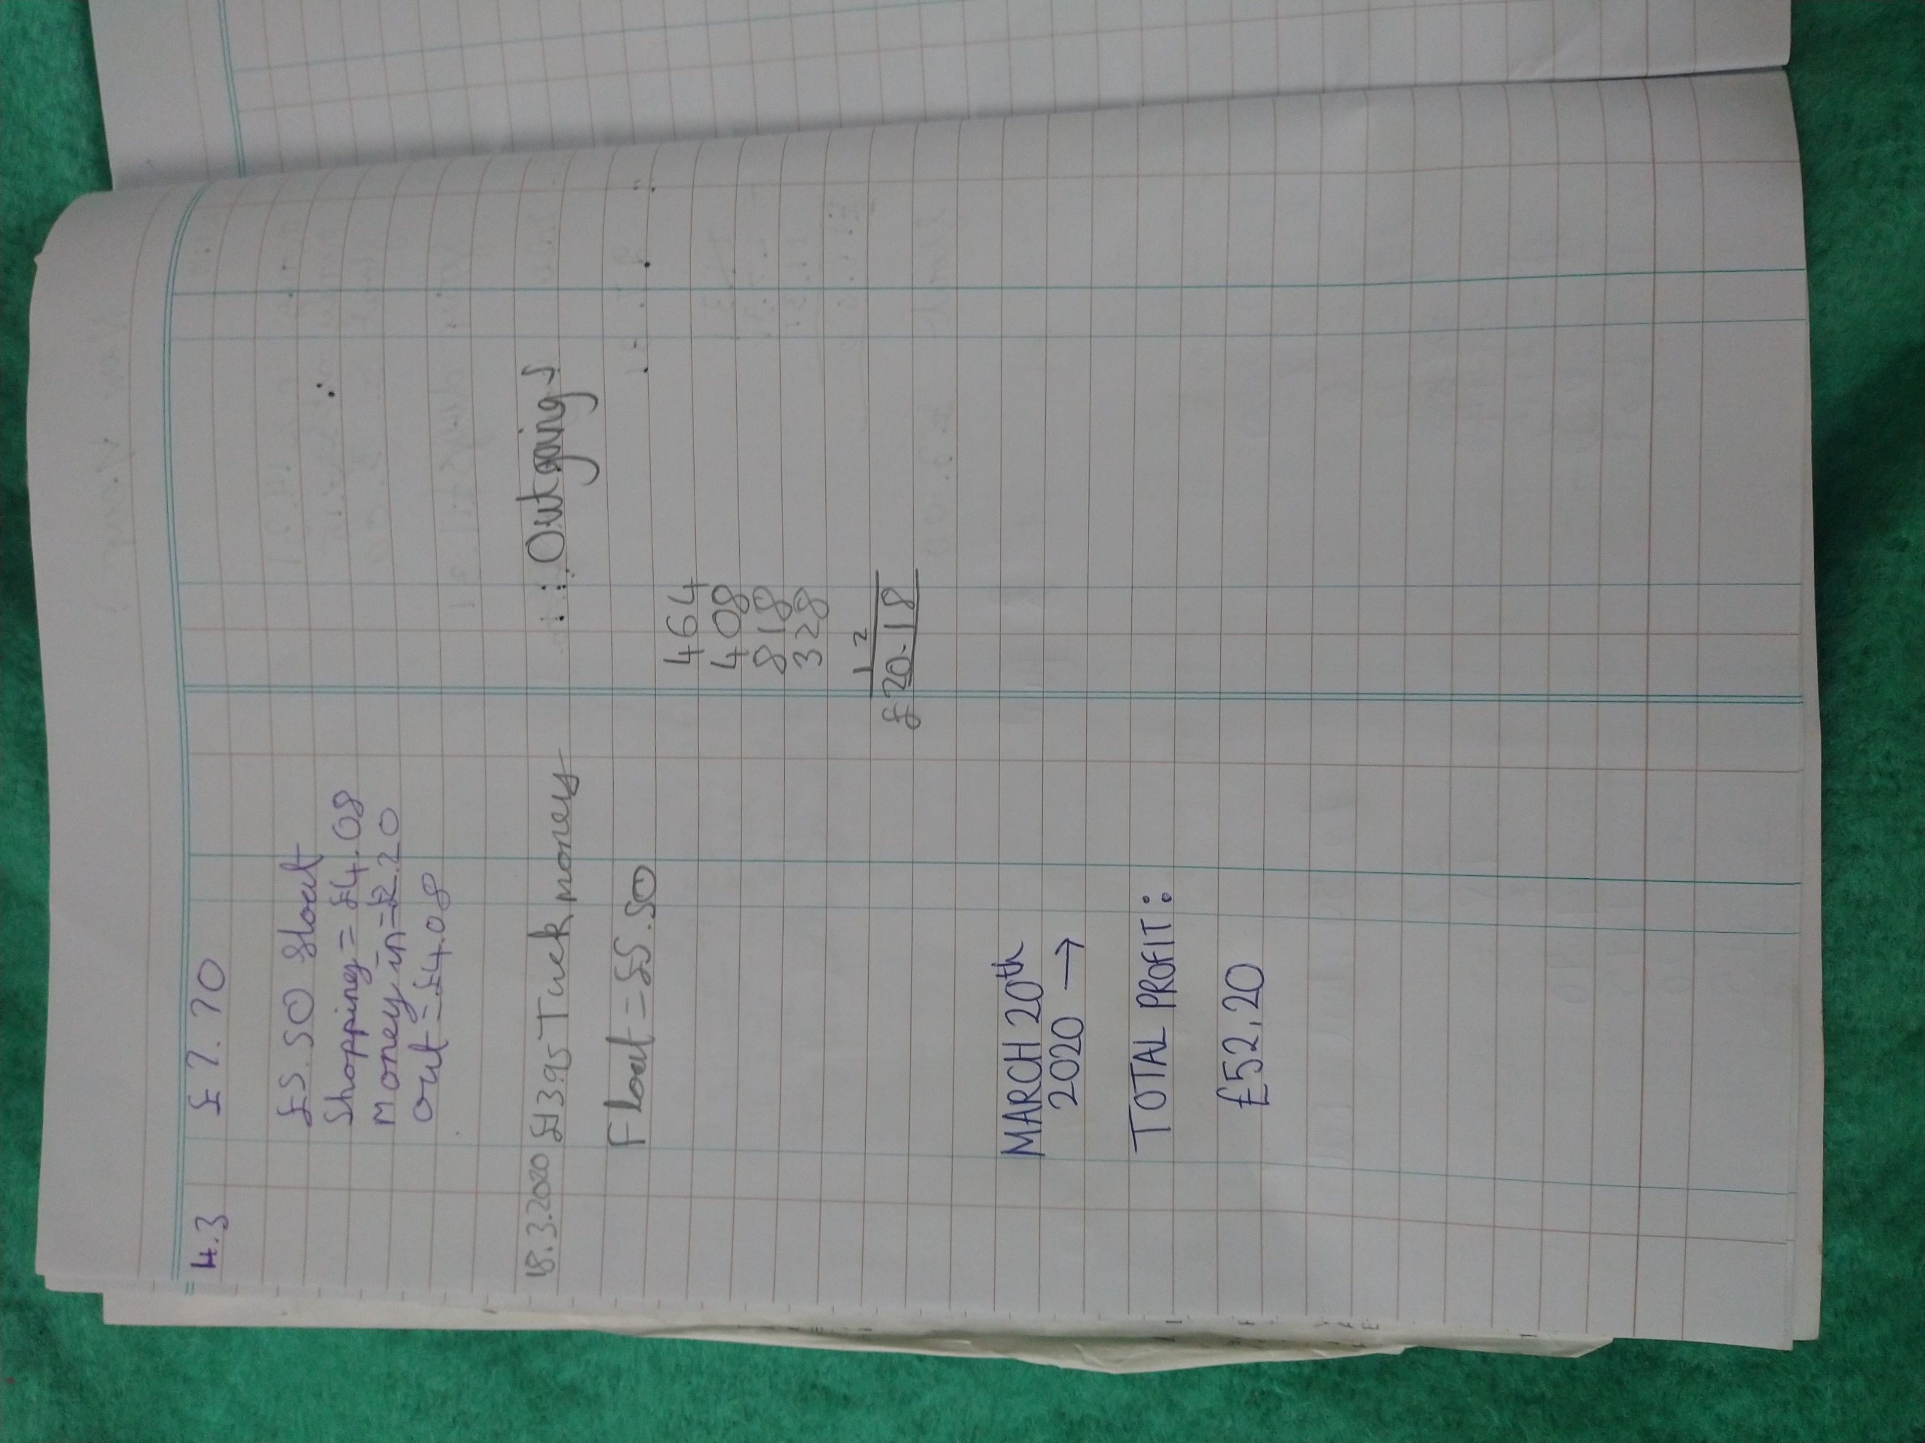

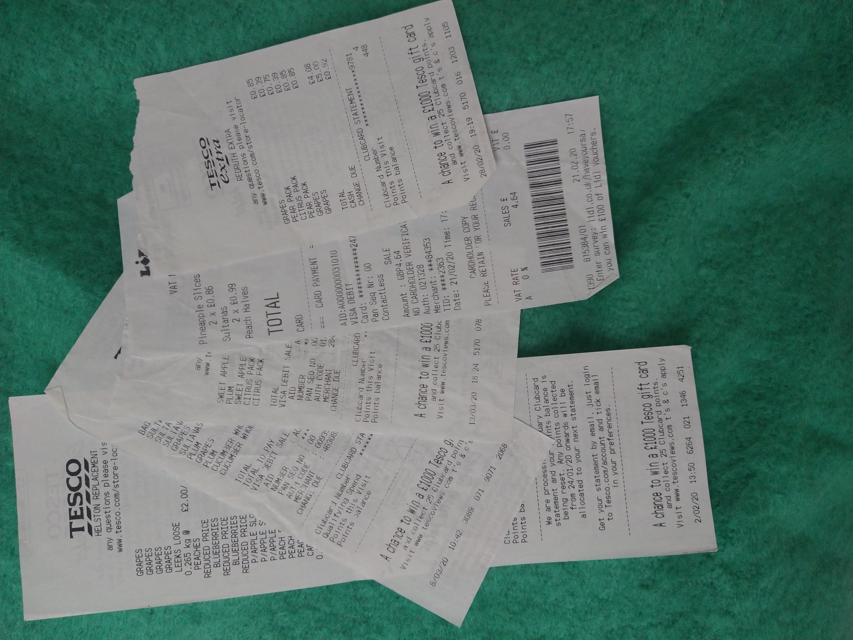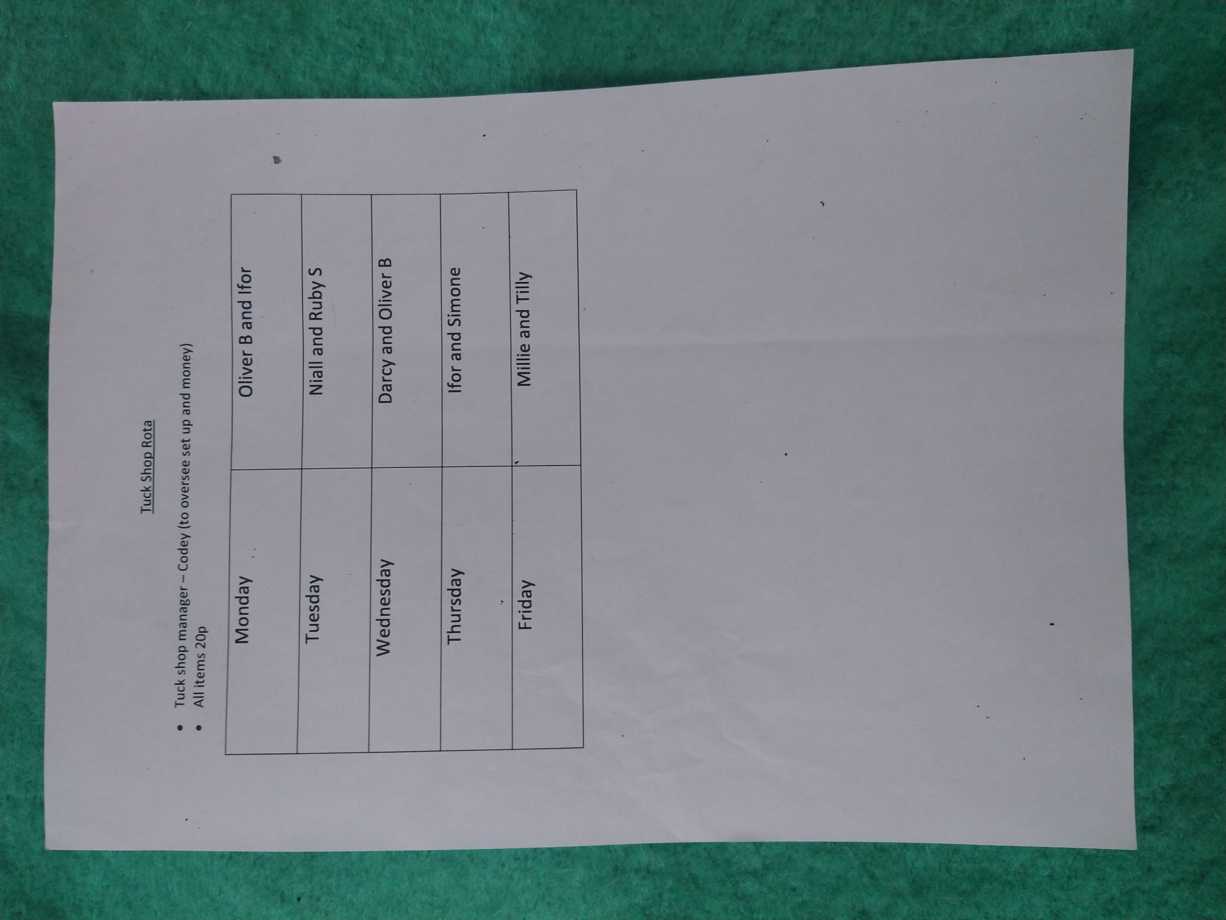

Sports and Wellbeing
We have reintroduced games makers to help people with playing different games. We make sure that there is equipment out in the playground and that everyone knows how to use it.
We were worried that children might be lonely or would like to make more friends so we have set up a friendship bench in the quiet area where you can go and someone will help you to have a good playtime. We needed new basketball hoops so we used the sports premium money and ordered new hoops for the playground. We are using the new shed in the bottom playground to store all of the equipment so that it gets used and looked after properly.

