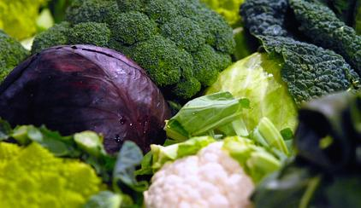



**Marlborough Lunch Menu**



Monday 22nd – Friday 26th May 2017

|  |  |  |  |
| --- | --- | --- | --- |
| Monday  Meat Free | 1 | Sweetcorn and red pepper pancakes  Tasty savoury pancakes with potato wedges and broccoli | V |
|  | **2** | **Tomato and sesame soup**  Smooth tomato, miso and tahini soup with raw veg sticks and Stones bread to dunk. | **V** DF V |
|  |  |  |  |
| Tuesday | 1 | **Pasta with pork ragu**  Wholemeal penne pasta served with slow cooked pork and tomato sauce with cheddar cheese and seasonal veggies |  |
|  | **2** | **Pasta with tomato and chickpeas**  Wholemeal penne pasta served in a tomato and chickpea sauce with cheddar cheese and seasonal veggies | **V** DF V |
|  | **3** | **Beetroot and brie tart**  Lattice topped flaky pastry pie with roast beetroot and Cornish brie, on the buffet bar with a range of salads | **V** |
|  |  |  |  |
| Wednesday | **1** | **Tuna meatballs**  Little tuna balls cooked in tomato sauce with wholemeal seeded couscous, fresh coleslaw and seasonal veggies |  |
|  | **2** | **Jacket potatoes**  Baked sweet or normal potatoes, served with organic baked beans, cheddar cheese, seasonal veggies and fresh coleslaw. | **V** DF V |
|  |  |  |  |
| Thursday | **1** | **Chicken roast dinner**  Roast free-range Cornish chicken, with roast potatoes, fresh chicken gravy and seasonal veggies | DF |
|  | **2** | **Vegan roast dinner**  Linda McCartney veggie sausages with roast potatoes, onion gravy and seasonal veggies | **V** DF V |
|  | **3** | **Spinach and feta filo pie**  Spanakopita pie, served warm on the buffet bar with a range of salads | **V** |
|  |  |  |  |
| Friday | **1** | **Beef lasagne**  Organic beef lasagne served with Stones garlic baguette and seasonal vegetables | DF* |
|  | **2** | **Roast veggie lasagne**  Summer veggie lasagne served with Stones garlic baguette and seasonal vegetables. | **V** |
|  | **3** | **Daal**  Creamy coconut daal, served with pitta breads, tomato salsa and raw veggie sticks for dunking. | **V** DF V |

Sometimes our seasonal veg is steamed, sometimes roast, sometimes stir fried, but we decide on it the day before to make sure we can make the most of what’s best value and available locally or more further afield. Same goes for our salads, we choose them the day before but ensure there’s always a good mix of simple and more adventurous, light and more filling.

|  |  |
| --- | --- |
| **V/V\*** | Vegetarian (including no fish) or can be made veggie on request if starred |
| DF/DF* | Dairy free (including no eggs) or can be made dairy free on request if starred |
| V/ V* | Naturally vegan or can be made vegan on request if starred |

Use the above key to choose options in regards to dietary requirements, ensuring the school know about all allergies and restrictions. If in doubt, please don’t hesitate to ask for advice in the school office.